Dr. Cheryl L Brown, Director  Jacksonville City Council  904.630.1452  CLBrown@coj.net | 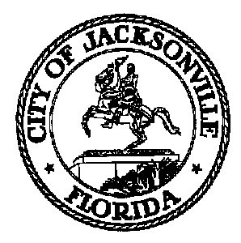 | 117 West Duval Street, Suite 425  Jacksonville, Florida 32202
TASK FORCE ON SAFETY AND CRIME REDUCTION

Meeting Notice
CANCELLATION

April 25, 2019
9:00 a.m.

TO: Task Force on Safety and Crime Reduction Subcommittee Chairs
Tom Geismar | Sabrina Edwards | Ronnie King
Richard Danford | W.C Gentry | Michael Munz
Frank Denton | Ellen Glasser | Shelley Grant

FROM: Mark Griffin, Chair

SUBJECT: 20190426 CANCELLATION Meeting Notice Task Force on Safety and Crime Reduction Subcommittee Chairs

Notice is hereby given that the Task Force on Safety and Crime Reduction Subcommittee Chairs Meeting has been CANCELED, and WILL NOT meet Friday, April 26, 2019 at 9:00 A.M. The meeting was to be held in the Lynwood Roberts Room located at 117 W. Duval St., 1st Floor, City Hall - St. James Building. For additional questions, please contact Crystal Shemwell or Carol Owens at 904-630-1404 or via email cshemwell@coj.net/cowens@coj.net.

When attending Task Force meetings, members are to park in the parking garage located on the corner of Main and Duval Street (Library Garage) to receive free parking. Please see the Legislative Assistant for parking validation.

CLB/clo
cc: Cheryl Brown, Council Director
Carol Owens, Chief of Legislative Services
Jeff Clements, Chief of Research
File
cityc@coj.net

Pursuant to the American with Disabilities Act, accommodations for persons with disabilities are available upon request. Please allow 1-2 business days notification to process; last minute requests will be accepted, but may not be possible to fulfill. Please contact Disabled Services Division at: V(904) 630-4940, TTY-(904) 630-4933, or email your request to KLMcDan@coj.net.

